Chapter 10, Solution 52.

We transform the voltage source to a current source.
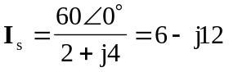
The new circuit is shown in Fig. (a).
(a)
I_{x}
4 
j4 
-j3 
I_{s} = 6 – j12 A
590 A
2 
6 
-j2 

Let 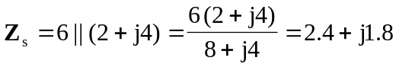

With these, we transform the current source on the left hand side of the circuit to a voltage source. We obtain the circuit in Fig. (b).
(b)
I_{x}
4 
-j3 
-j2 
+
−
V_{s}
j5 A
Z_{s}

Let
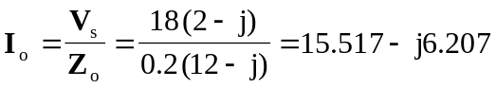

With these, we transform the voltage source in Fig. (b) to a current source. We obtain the circuit in Fig. (c).
(c)
I_{x}
4 
-j3 
I_{o}
j5 A
Z_{o}

Using current division,
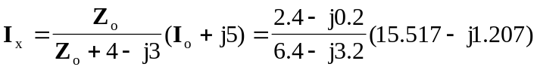

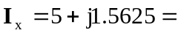 5.23817.35 A

